HIBERNIANS BASKETBALL CLUB
Disciplinary Code explainer
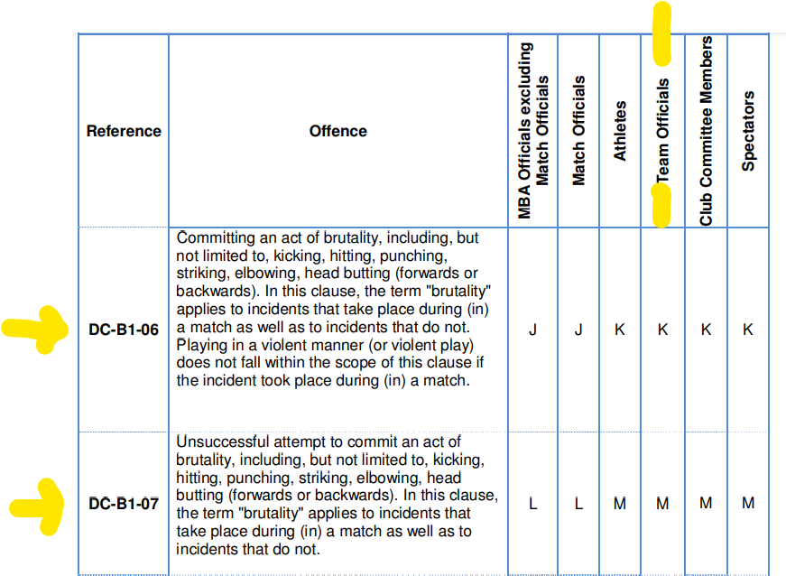
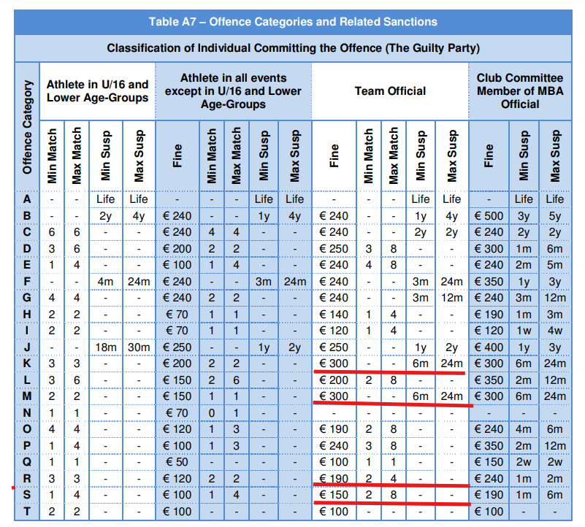
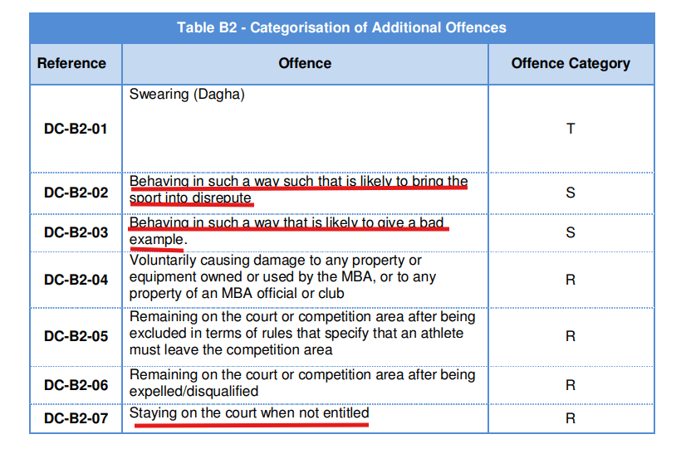

Offence Categories in Table A7
From Table B2 (Categorization of Additional Offences):
- DC-B2-02 (Behaving in a way that brings the sport into disrepute) → Category S
- DC-B2-03 (Giving a bad example) → Category S
- DC-B2-07 (Staying on the court when not entitled) → Category R

Now, referring to Table A7 (Offence Categories and Related Sanctions):
Offence Category | Fine | Minimum Suspension | Maximum Suspension
S | €190 | 1 month | 6 months
R | €240 | 1 month | 2 months

Applying the Restricted Area Penalty
Since the offence was committed in a Restricted Area, per DC-A5 (General Rules), sanctions are doubled. This means:
- Fines are doubled (€380 for S category and €480 for R category).
- Suspension periods are also doubled.

